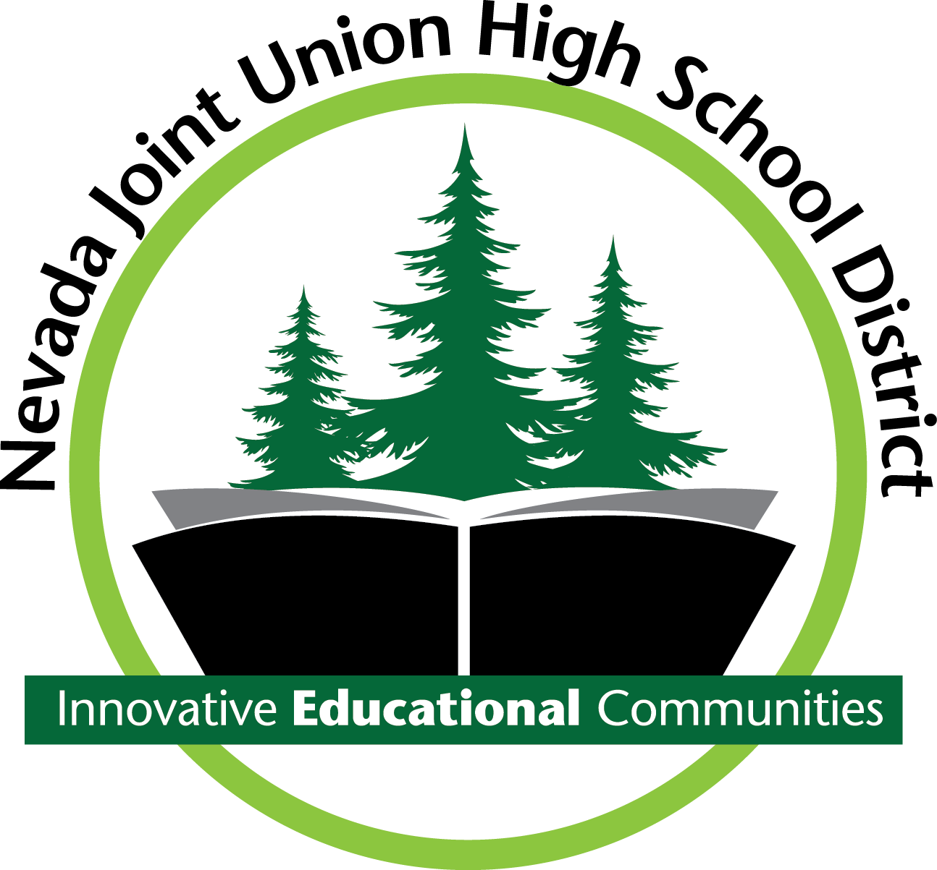

NOTICE

OF

PUBLIC HEARING

Sufficiency of Textbooks & Instructional Materials

The Nevada Joint Union High School District will hold a public hearing to consider the sufficiency of textbooks and instructional materials in the District for the 2018-2019 school year and that they are consistent with the content and cycles of the curriculum frameworks adopted by the State Board.

The meeting will be held on:
Wednesday, September 12, 2018, 6:00 p.m.
Bear River High School
11130 Magnolia Road
Grass Valley, Ca. 95949

